

THE HERITAGE

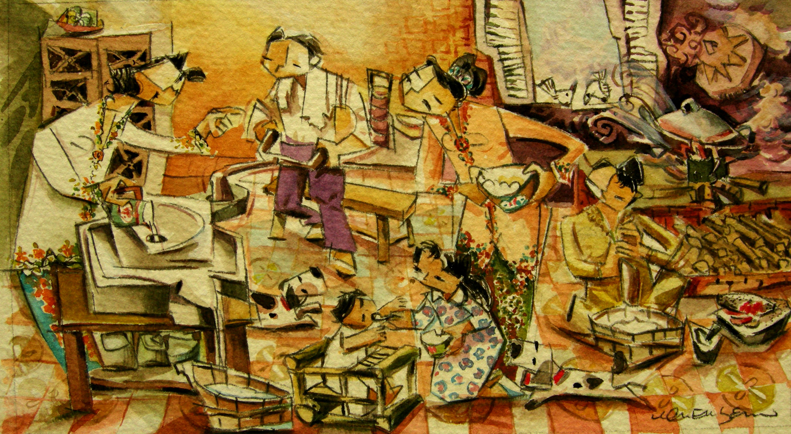
‘Hari Tumbuk Tepong’
Rice is shifted, sorted, soaked and then milked and pounded in stone mortars. The ‘Hari Tumbuk Tepong’ takes place two days before the wedding.

